Upcoming Events
November 2019 Synodical Board Meeting by teleconference
2020
January 31 End of financial year
March 28 Dallas Metro North Spring Retreat, Preston Meadow, Plano
8:30 – 4:00, Daycare will be provided.
The theme will be about how to include women of all ages.
April 4 Heart of Texas Spring Gathering at St. Matthew, Waco
Spring Eastern Cluster/Eastern Conference Spring Gathering
First, Longview
July 16-19 National Gathering 2020 in Phoenix, Arizona “JUST LOVE”
2nd weekend in October NT-NL SWO Synod Convention, Metro West conference

NT-NL Synod Convention special guest to celebrate the ordination of women

The year 2020 will be the 50th anniversary for ordination of women in the Lutheran church. At synod assembly next year, we would like to have a special artist come and present her work on women in the Old Testament. Her name is Sarah Novenston. The cost is about $4000. We are looking for funds to help defray the costs. Please consider having you church donate. In addition, a special service will be held and we would like as many women as possible to attend. Watch for more details as to time and place. Contact Sandra Gass to let her know if and how much you choose to donate. Her email address is gass@att.net.

Heart of Texas begins planning for Spring Gathering
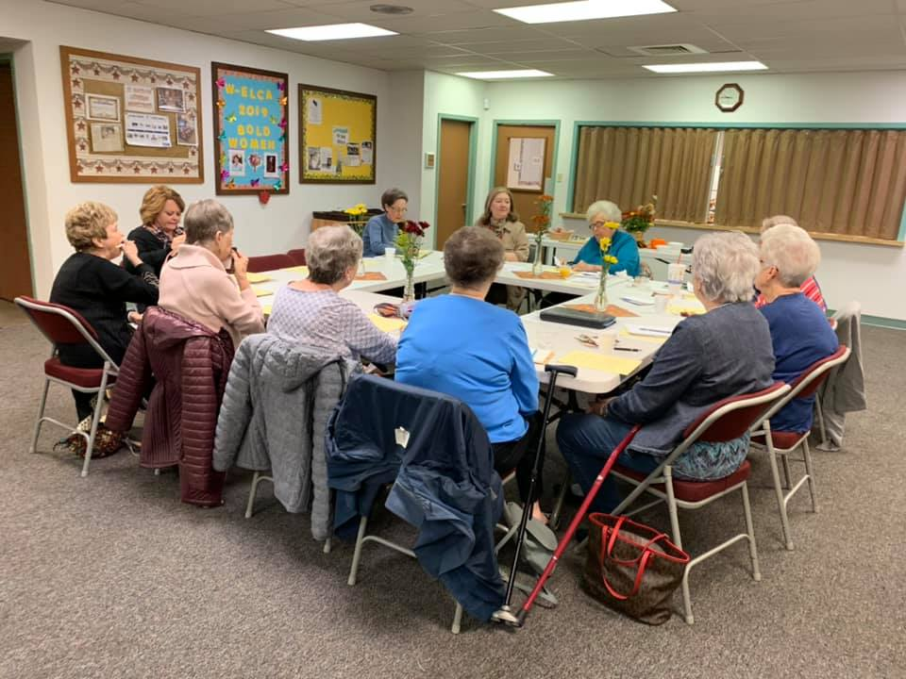

The women of First Lutheran and St. Matthew churches in Waco met to begin planning the Heart of Texas Spring Gathering. Their gathering will be held on Saturday, April 4, 2020 at St. Matthew Lutheran Church. Mark your calendar!

Share upcoming events of your unit and conference to our Facebook page, https://www.facebook.com/ntnlswo/.
You can also email news to ntnlwelca@gmail.com and it will be included in the next newsletter.

