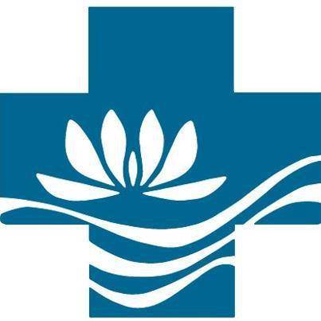

W O M E N

of the
Evangelical Lutheran Church in America

Conference Coordinator
Handbook

Northern Texas-Northern Louisiana
Synodical Women’s Organization

Rev. 8/2025
, August 2025
Dear sisters in Christ:

Welcome to an updated version of the Conference Coordinator’s Handbook for the Northern Texas-Northern Louisiana (NT-NL) Synodical Women's Organization (SWO). This handbook is provided as an easy resource for members of Congregational Units (CU), Conferences/Clusters, and the Executive Board to use as a reference and guide as we engage in ministry and action. Included in the handbook is a collection of plans, policies, and forms. As a Board, we have continued to work conscientiously to offer you a tool that will provide you with guidance and direction for questions that may arise. We have worked to update the handbook to furnish the most current information. We hope that you will utilize this tool. We realize that all your questions may not be addressed in this handbook and that you might require additional information. We encourage you to contact any Board member or Conference leader to assist you in finding clarification or an answer for your questions and concerns. If you find areas in the handbook that need further explanation, we encourage you to provide us with suggestions. We hope that the digital availability of this handbook at https://ntnllutheranwomen.com will help keep it current and accessible.
Blessings in all that you do as Women of the ELCA.

Northern Texas-Northern Louisiana Synodical Women’s Organization Board

References:
Conference Coordinator's Handbook Women of the E. L. C. A
North Texas/North Louisiana Synod W-ELCA 1997

Conference Coordinator's Handbook Women of the E. L. C. A
Southwest Texas Synod
W-ELCA March 17, 2017

Leadership Manual
Women of the E. L. C. A
Florida-Bahamas Synod
W-ELCA July 2021

https://welca.org

Synodical Leaders Guide 021325Update

Table of Contents
Women of the ELCA 4
Mission: 4
Purpose: 4
Expressions: 4
2024-2026 WELCA Goals 5
WELCA Logo 5
Conferences/Clusters 6
Purpose 6
Conference Activities 6
Conference Coordinator 6
Map of NT-NL Conferences 7
Planning Conference Events 7
Conference Finances 7
Conference Secretary 8
All Conference Leaders 8
Congregational, Inter-congregational and Special Units 9
Mission 9
Purpose 9
Commitments 9
Synodical Women’s Organization 10
Churchwide Women’s Organization 12
Mission: 12
Purpose: 12
Responsibilities 12
FORMS – refer to https://www.ntnllutheranwomen.org 13

Women of the ELCA

Mission: | Mobilizing women to act boldly on their faith in Jesus Christ.
Purpose: | As a community of women created in the image of God, called to discipleship in Jesus Christ, and empowered by the Holy Spirit, we commit ourselves to grow in faith, affirm our gifts, support one another in our callings, engage in ministry and action, and promote healing and wholeness in the church, the society, and the world.
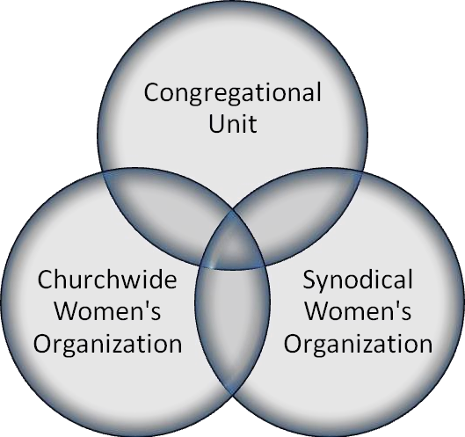  Expressions: | WELCA is the women’s ministry organization of the ELCA. It is separately incorporated and is not an auxiliary of the church. It is financially independent and responsible for its own financial affairs. Financial support comes from individual and group offerings and gifts.  There are three expressions of Women of the ELCA, each with its own constitution. For more info, see the Appendix  - Congregational (CU), inter-congregational (ICU) and special units (about 4,000) are the largest expression of the organization and are the heart of the organization. This is where we grow the organization, inviting women to experience the reconciling and transforming love of God through Jesus Christ, encouraging women to act on their baptismal covenant.  - Synodical Women’s Organization (SWOs) There are 64 SWOS in the ELCA’s 65 synods. SWOs establish a partnership with units in their geographic areas and with the churchwide women’s organization. SWOs exist to support women in congregations. Each SWO has a board whose members are elected at an annual or biennial convention by voting members from units. Each SWO establishes clusters or conferences of units within its geographic area.  - Churchwide Women’s Organization (CWO) is the entire organization. Within the churchwide expression of Women of the ELCA, the Triennial Convention is the highest legislative authority; voting members to the convention are elected by synodical organizations. Between conventions, the churchwide executive board (volunteers elected by the Triennial Convention) conducts the business of the organization.

Women of the ELCA (continued)

2024-2026 WELCA Goals | Five goals for 2024-2026 were taken from conversations with staff, executive board members, synodical women’s organizations (SWO) presidents, and participants of Women of the ELCA. An online survey that drew more than 200 responses was also used in gathering information for the plan.  - Connect with women who are not yet affiliated with Women of the ELCA, to communicate Christ’s love and affirmation and to engage them in our circle of care that we might support and affirm their gifts and callings along with those of all the women currently in the organization.  - Create new resources that help women in a variety of contexts to grow in faith, affirm their God-given gifts, and follow their callings.  - Complement existing resources with new funding sources as well as a strong stewardship model that focuses on the generous sharing of the God-given gifts of our time, talents, and treasure.  - Continue existing ministries and programs that nourish and strengthen participants in Women of the ELCA and the ELCA.  - Celebrate our vibrant community and our goals together!  There was remarkable consensus on the four goals and the plan parallels that of the ELCA and the Lutheran Men in Mission. For more details on tactics, go to https://www.womenoftheelca.org/about
WELCA Logo   | Our logo—with the cross, water and a white lily—identifies women of the Evangelical Lutheran Church in America as children of God; baptized, forgiven, adopted into God’s family, full of grace and hope in eternal life. It is a reminder of the growth, beauty, and vitality that rises out of that life-giving baptismal water. It is also a reminder of the mission of the church to “Go, therefore, make disciples of all nations; baptize them in the name of the Father and of the Son and of the Holy Spirit” (Matthew 28:19). For more details on the use of the logo, go to https://www.womenoftheelca.org/logo-licensing-agreement

Conferences/Clusters

Purpose | Conferences are charged with working interdependently with the SWO and the units to fulfill the purpose of Women of the ELCA through activities. Conferences and clusters are designed to be bridges by providing a way for women to gather more frequently and locally.
Conference Activities | The activities that are to be carried out must meet five criteria, as established in the synodical constitution.  The activities will:  - provide experiences for learning and leadership development,  - build community,  - provide opportunities for joint ministry and action,  - provide opportunities for stewardship education and offerings, and  - establish networks for communication.  Often conferences or clusters meet once in the spring and once in the fall of each year, moving the meeting location around the geographical area of the conference or cluster. The activity planned for that meeting would meet the criteria set forth above. Often a different synodical board member will be assigned as a liaison to each conference or cluster and will work with the conference/cluster leadership to develop the activities.
Conference Coordinator | In some synodical organizations, each conference or cluster’s leader (often called a coordinator) also serves as a liaison back to the synodical board. This is an effective tool for involving more women in the synodical organization and its ministries.  Business meetings are minimal. The Coordinator should have a well-planned agenda and be familiar with basic parliamentary procedures.

Conferences/Clusters (continued)

Map of NT-NL Conferences | 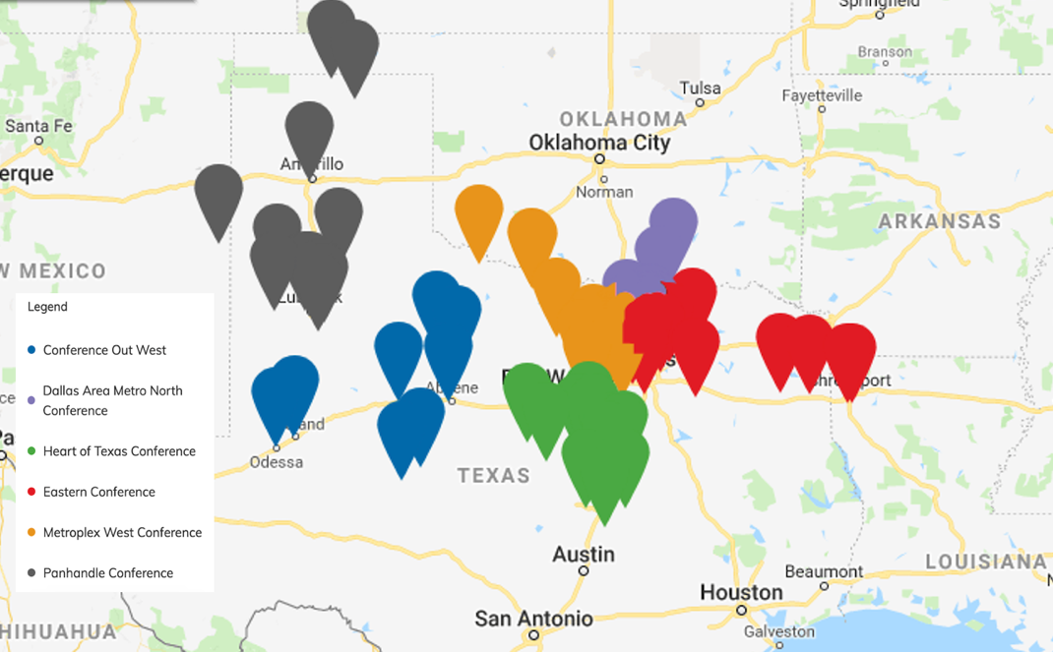
Planning Conference Events | - Plan meeting to fulfill purpose of W-ELCA by serving as a liaison between the SWO Board and CU/ICUs  - Seek capable women to serve as conference leaders and/or volunteers  - Plan worship service with host congregation and host pastor  - Plan expenditures-cost of meals, travel expenses, honorariums, etc. (DO NOT USE OFFERING)  - Plan schedule for publicity and method of informing each congregational and inter-congregational level. Assign these responsibilities.  - Extend invitations to SWO Liaison person and SWO Board members.  - Suggest and/or help plan offering designations.  - Add responsibilities as needed; i.e. Host congregation, etc.  - Conduct the conference meeting.  - Debrief what worked and suggestions for the next time.
Conference Finances | Conference/clusters may not have treasurers or treasuries. Conference/cluster planners are encouraged to budget carefully so that their events come as close as possible to paying for themselves and not be overly dependent upon unit or synodical women’s organizational funds. The monies of the conference/  cluster are forwarded to the SWO Treasurer, who displays separate revenue and expense lines for the conference. It is the responsibility of the synodical treasurer to oversee these items.

Conferences/Clusters (continued)

Conference Secretary | Conference/clusters may not have secretaries. Conference planners are encouraged to:  - record conference CU/ICUs, including names and addresses of the CU/ICU leaders  - keeps minutes of conference meetings and a record of other conference events.  - works with conference coordinator and conference leaders in planning and implementing conference events.  - sends conference reports to SWO and CUs within 30 days after meeting/event; include financial report.
All Conference Leaders | - Plan and provide regular meetings annually/biennially  - Transfer all materials to successor within 21 days of election  - Term of conference leaders and board members shall be determined by conference  - No person may serve the Women of the ELCA SWO in two offices at the same time; if elected or appointed to SWO Board, the Coordinator may:  - poll her CU presidents for a replacement,  - immediately find a replacement in a creative Christian manner.

Congregational, Inter-congregational and Special Units

Mission | Mobilizing women to act boldly on their faith in Jesus Christ.
Purpose | As a community of women created in the image of God, called to discipleship in Jesus Christ, and empowered by the Holy Spirit, we commit ourselves to grow in faith, affirm our gifts, support one another in our callings, engage in ministry and action, and promote healing and wholeness in the church, the society, and the world.
Commitments | To accomplish the purpose of Women of the ELCA, women in this unit shall commit themselves to:  - come together for study, support and action;  - participate in the ministry of Women of the ELCA beyond the congregation;  - support financially the total program of Women of the ELCA; and  - designate leadership that shall be in communication with the synodical and churchwide women’s organization. (Article II Section 2.)  The way that each unit lives out these commitments may vary, limited only by the imagination and resources of the women participating in the unit. All are encouraged to subscribe to the organization’s publications and use its resources.  Ideally, units would collect:  - regular offerings and submit a portion of them to their synodical organization (which, in turn, submits a portion of those regular offerings to the churchwide organization).  - hold one or more Thankoffering services each year and transmit to the churchwide organization 100 percent of the Thankofferings collected.  - participate in special offerings and designated gifts, as appropriate.

Synodical Women’s Organization

Mission | Mobilizing women to act boldly on their faith in Jesus Christ.
Purpose | The constitution states: “The purpose of this synodical women’s organization shall be to assist units within its territory to fulfill the purpose of Women of the ELCA.” (Constitution and Bylaws, Synodical Women’s Organization, Article II, Section 1). Women of the ELCA has 64 synodical women’s organizations.
Map of NT-NL Synod | 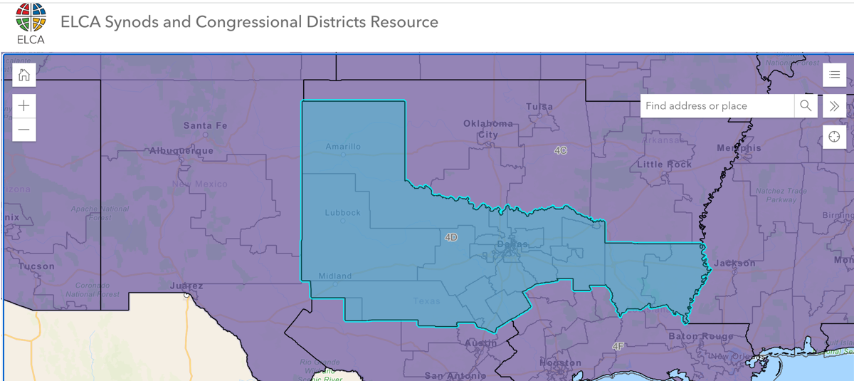
Function | The legislative function of the SWO is fulfilled by the synodical convention, held biennially, with the synodical board (elected volunteers) exercising interim legislative authority. While planning and carrying out a convention can be a large task, it should not overshadow the work of the board in assisting units to fulfill the purpose of Women of the ELCA.
Responsibilities | It is the responsibility of the SWO to be in close contact with the units in its territory. Contact with established units should include but is not limited to:  - obtaining and maintaining a copy of each unit’s constitution;  - establishing and maintaining contact information for the unit’s leadership;  - informing units of actions taken by the executive board;  - interpreting and explaining those actions;  - introducing resources produced in the churchwide office;  - educating units as to the use of these resources;  - informing units of programs available through the synodical organization and presenting said programs at their meetings;  - assisting with the formation of new units; and  - communicating the emphasis selected by the synodical board for projects, programs, and events.  Efforts should be made to establish a new unit in churches without one.
About Synodical Women’s Organization (continued)

Active Unit Assessment | Every three years, the churchwide office requests each synodical president verify a list of ELCA congregations in her territory, producing the most current list of those congregations having units. (SWO presidents should request a current list of congregations from the office of their Synod Bishop.) The president is asked to use this Active Unit Assessment to establish which congregations continue to have active Women of the ELCA units. This listing is used by the churchwide organization to establish the number of voting members per synodical organization for the next triennial convention.

Churchwide Women’s Organization

Mission: | Mobilizing women to act boldly on their faith in Jesus Christ.
Purpose: | As a community of women created in the image of God, called to discipleship in Jesus Christ, and empowered by the Holy Spirit, we commit ourselves to grow in faith, affirm our gifts, support one another in our callings, engage in ministry and action, and promote healing and wholeness in the church, the society, and the world.
Responsibilities | - The churchwide organization exists to support women in units as they carry out our shared mission and purpose.  - The churchwide organization also coordinates the ministry of women across the church, exercising many functions and responsibilities.  - The legislative function of the churchwide women’s organization is fulfilled by the triennial convention, with the executive board members (elected volunteers) exercising interim legislative authority and serving as the board of directors.  - The executive board provides vision and enacts policies which are brought to life by staff.  - The executive director and staff plan a comprehensive program that supports women within the organization as they live out Women of the ELCA’s mission and purpose. This plan involves leadership development, communication resources and networks, racial justice resources and network, global education, a health initiative, financial support, program resources, and more.

FORMS – refer to https://www.ntnllutheranwomen.org
- Retreat Agenda Template
- Retreat Outline Worksheet
- Retreat Registration Template
- Retreat Survey Template
- Retreat Registrations Template tracking in Excel

